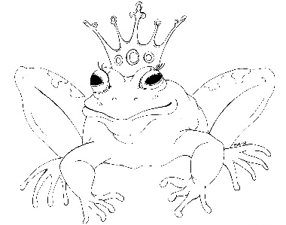
From the Desk of E.D. Baker
The Frog Princess – Discussion Questions

​
What do you think would have happened if Emma had not gone to the swamp to avoid Prince Jorge?

​
​
Why didn't Emma want to kiss the frog? What would you have done in her place?

​
​
What do you think the most difficult thing to learn about surviving as a frog would be?

​
What do you think happened to Mudine?

​
​
What do you think Vannabe did after the animals escaped from the cottage?

​
​
How did Grassina help Emma and Eadric after she learned about their dilemma? Why didn’t
she do more to help them?

​
​
Choose a scene from The Frog Princess. What did you like about it? What would you have added to make it even more descriptive?

​
​
How would you describe Emma’s and Eadric’s personalities?

