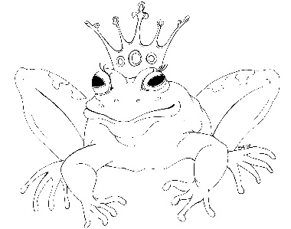
From the Desk of E.D. Baker

A Question of Magic: Discussion Questions

Why was Serafina's family so excited about the letter before she'd even read it?

When did Serafina realize that she really couldn't go home?

Why couldn't the cottage take Serafina closer to her parent's home?

Why did Serafina have such a hard time getting more blue rose tea?

How did Serafina feel about being Baba Yaga?

What did the woman who brought the tarts do that made Maks dislike her?

How did Serafina affect the outcome of the war?

How did Serafina and Auster become friends?

Why did Dielle want to be the next Baba Yaga?

In what ways did Maks help Serafina?

Why did Maks and the skulls like Serafina so much?

