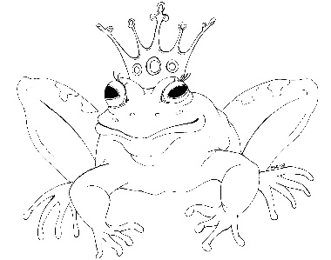
From the Desk of E.D. Baker
Bravest Princess – Discussion Questions

How did Gwendolyn and her bridesmaids treat Annie before the wedding?

How was someone able to put the green fire in Annie's hair?

When Beldegarde was a bear, his brother, Maitland, wanted to get him out of the way so he could inherit the crown himself. Why would Beldegarde forgive him? Would you have forgiven Maitland if you were Beldegarde?

Annie helped Snow White create tests for the princes. If you were to create another test, what would you have them do?

What do you think happened to Tandry after his mother turned into snail slime?

Mother Hubbard seems like a nice person. If she knew what kind of magic her relatives practiced, how do you think she would have treated them?

Mother Hubbard didn't want King Archibald to execute Granny Bentbone. If he hadn't sent the nasty witch to the tower, what could he have done with her?

Annie asked Snow White what she was looking for in a prince. What other qualities would you have mentioned?

Other than Maitland, what other candidates for Snow White's hand would have made a good king?

Annie touched each of the women in the castle, trying to find Terrobella and Marissa. What else could she have done to find the witches?

What do you think the face in the magic mirror looked like?

