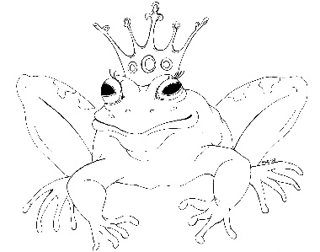
From the Desk of E.D. Baker
Princess Between Worlds – Discussion Questions

If you could choose anywhere in Annie's part of the world to visit on your grand tour, where would you want to go?

What do you think Liam should do with his mother and brother?

If Prince Rupert hadn't had a miniature portrait of Annie, what do you think she could have said or done to prove her identity when she arrived at Delaroo Pass?

Why do you think that the people in Westerling believe that the yeti are all bad and that there are no yeti families?

What do you think happened to Prince Nasheen and Sarina after Annie and Liam disappeared?

If Rotan had talked to the giants, how do you think they would have acted toward Annie and Liam?

What do you think would have happened if Annie and Liam hadn't left the giants' island when they did?

Choose a location from the story. Using all five out your senses, describe the setting.

Shoppers in the Magic Marketplace grew excited when they smelled dragons. What do you think would have happened if they'd discovered that Millie and Audun could turn into dragons?

No unauthorized magic is allowed in the Magic Marketplace. What other rules would you make for the marketplace if you were in charge?
What other jobs might a sprite take on in the castle?

Which do you think is more powerful – a vampire or a sprite?

