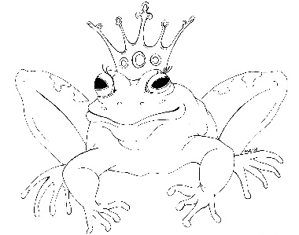
From the Desk of E.D. Baker
No Place For Magic – Discussion Questions

​
​

Why do you think Emma and her mother still had such a strained relationship?

​
​
In the beginning of the story, why didn’t Eadric’s parents like Emma? How do you think they would have felt about her if she hadn’t been a witch?

​
​
Who accompanied Emma and Eadric to Upper Montevista? Who did they meet along the way? What did Emma learn from the people she met?

​
​
If you were Emma and could come up with a magic spell, but didn’t want anyone to know that you had, what would you have done to stop the drunken giant?

​
​
What did Eadric’s parents think had happened to Bradston? What really happened?

​
​
What did Emma and Eadric do to escape from the cockatrice breeding ground? What would you have done differently?

​
​
How would you describe the troll queen’s four heads? If you were to write about a troll, how many heads would it have and what would they be like?

​
​
Who defended the castle when the trolls attacked and what did they do to defend it? How did the troll queen get inside?

​
​
How did Emma’s ability to turn into a dragon help her in this story? What decisions did it force her to make about Eadric?

​
​
If you could become a dragon, how would it change your life?

​
​
Who else do you think Emma and Eadric should have invited to their wedding?

​
​
By the end of the story, how did Eadric’s parents feel about Emma being a witch?

