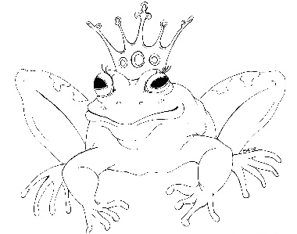
From the Desk of E.D. Baker
Princess Before Dawn – Discussion Questions

Squidge had ruined Annie and Liam's first wedding. They were planning Liam's coronation when Squidge returned. What would you have done if you were Annie or Liam and he asked you to trust him?

Witches, vampires, satyrs, nymphs and dwarves arrived in Treecrest unexpectedly. What other beings that didn't stop by the castle might have used post cards to visit the kingdom?

Which uninvited guests were worse, the witches or the vampires?

What do you think the vampires of Tottington would have done if they hadn't been afraid of Audun, the dragon?

What do you think the vampires in Heartsblood Manor did once they discovered that the wraiths were gone?

Why didn't Annie's companions see the wraiths when Annie did?

Francis used Emma's old spell to release Li'l from the cage in the vampire's dungeon. Come up with your own spell that Francis could have used to rescue Li'l.

What do you think the Duke of Highcliff did after he returned home?

Many of the vampires don't respect Zoe because she's only half vampire. What can Zoe and her father do to change their opinions?

What other jobs might a sprite take on in the castle?

Which do you think is more powerful – a vampire or a sprite?

