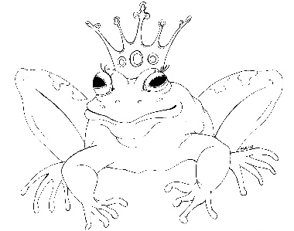
From the Desk of E.D. Baker
Dragon’s Breath – Discussion Questions

​
​
Why did Olivene want to keep Haywood and Grassina apart? How successful was she?

​
​
Why did Olefat steal the old witches’ personalities?

​
​
Do you think the way the witches from the Old Witches Retirement Community punished Olefat Wizard was appropriate? What about Metoo? What would you have done differently if you had been one of the witches?

​
​
What do you think Nastia Nautica did when she woke up?

​
​
What other magical objects do you think Emma and Eadric might have found for sale in the magic marketplace?

​
​
If you were a dragon, what would be your favorite event in the Dragon Olympics?

​
​
What did Emma do that allowed her to be called a dragon friend?

​
​
Why was Olivene so hard on Grassina?
​
​
​

