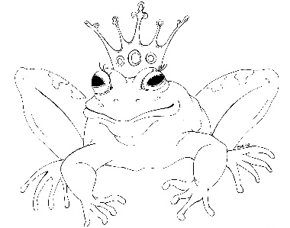
From the Desk of E.D. Baker
Once Upon A Curse – Discussion Questions

​
​
Where did Emma look for a way to end the family curse?

​
​
Why was it so important to Emma that she end the curse?

​
​
Why didn’t her family believe that she could do it?

​
​
Why didn’t Haywood want to kiss Grassina? What do you think would have happened if he had?
​

​
What did Emma plan to do when she went back in time?

​
​
How did Emma’s presence in the past affect what happened? Do you think that the Swamp Fairy would have said the curse if Emma hadn’t gone back in time and made the changes that she did?

​
​
Who was the real first Green Witch?

​
​
How do you think Li’l reacted when Garrid came to see her after the tournament?
​
​

