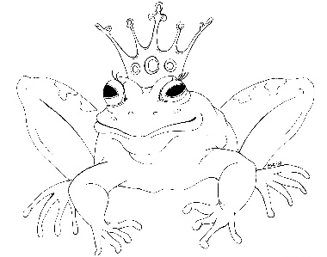
From the Desk of E.D. Baker
The Wide-Awake Princess – Discussion Questions

Magic couldn't touch Annie. How do you think this would have made her life easier? How would it have made her life harder?

What other way could someone have brought a spinning wheel into the castle?

What would Annie's life had been like if she had stayed in the castle after everyone fell asleep?

Create a prince that you would have wanted to wake up Gwendolyn if Beldegarde hadn't been there.

When Annie learned that Liam had misled her about his real identity, what should she have done?

What other kinds of contests could Prince Andreas have included in his search for a bride?

Whey were the tiny fairies so mean to Annie when she met them in the forest?

What do you think of the way Annie's family treated her before the curse took hold and after they woke up?

Write a poem that you could have entered into Prince Andreas's contest. It can even be a limerick!

The fairy Sweetness and Light really wasn't very sweet. If you had to give her a name that fit her better, what would you have called her?

If Liam didn't trust Clarence, do you think Liam was right to bring his brother to the castle to kiss Gwendolyn?

After the Treecrest soldiers defeated Clarence's men, Clarence ran off. What do you think he did next?

