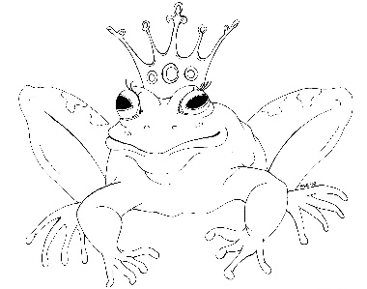
From the Desk of E.D. Baker
Fairy Tale Matchmaker – The Truest Heart – Discussion Questions

Who was the first Big Baddy to come after Cory?

Where do you think the Loch Ness Monster (Old Gnarly) went when he disappeared from beneath Blue and the ogres?

Why do you think Delphinium and Officer Deeds would make a good match?

Why did Micah act the way he did when he learned that Cory had matched him with Quince Brookfield?

How else could Laudine Kundry have learned the truth about Cory? Would it have been as effective?

What would have happened in the court room if Cory hadn't matched Delphinium and Officer Deeds?

Why do you think Cory hasn't found a match for Daisy yet?

Why did Laudine think she had the right to find out the truth about Cory?

Who else could have given Shimmer a home?

Why was it so important that WU didn't side with the Tooth Fairy Guild?

Why was Blue unhappy that Cory hadn't talked to him about moving to Lionel's house before she made her decision?

