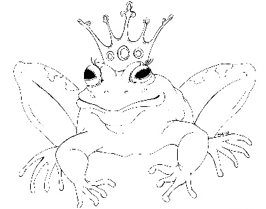
From the Desk of E.D. Baker
Fairy Tale Matchmaker: The Perfect Match – Discussion Questions
Why do you think Prince Rupert insisted on giving the baby dragon to Princess Lillian even though she was afraid of dragons?

Was Cory right to match Prince Rupert with Goldilocks when he was about to marry Princess Lillian?

Why do you think the servants and courtiers stay in Dorrigal when life would be much easier for them in the city?

When Cory told Princess Lillian that Prince Georgie was a thief, why do you think the princess didn't believe her?

How did Cory end up owning Shimmer?

Who do you think the 'Big Baddies' are in the Itinerant Trouble-makers Guild?

Why are so many guilds turning against Cory?

Why did Itchy Butt make such a bad first impression on Cory?

What other method could Wanita have used to reveal which cockroach was Theo?

How do you think Jonas should market his gossiping grapes, watching potatoes and listening ears of corn?

Which guild do you think was the nastiest to Cory?

