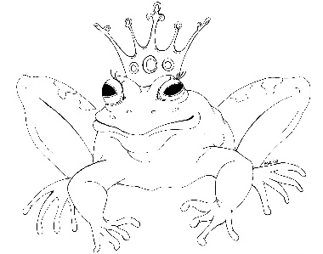
From the Desk of E.D. Baker
The Princess and the Pearl – Discussion Questions

After Annie and Liam learned that her father wasn't feeling well, why did they leave the next day?

Why would the fortress at Deephold be a good place to leave Clarence?

How do you think Annie's grandfather got the creeping blue?

Annie invited all the doctors and herbalists in the kingdom to come to the castle. Before she left to find Ting Tang, was there anyone else she could have consulted?

Why did Annie and Liam trust Clarence to guide them to Skull Cove?

Annie didn't want to let anyone know that Millie and Audun could turn into dragons. What would you have done if you were in Annie's position?

If Millie and Audun hadn't been with them, what do you think Annie and Liam would have done when the pirates attacked?

Why were all those people in Rupert's room when Annie returned with the cure?

What do you think Clarence did after Annie and Liam left and Ting Tang untied him?

Why do you think the pirates stopped the carriage as it was headed to Treecrest?

Annie and Liam left Queen Lenore on the island with the witches. What do you think Queen Lenore did when she was alone on the island while the witches went to see why Annie and Liam were looking for the sea monster?

