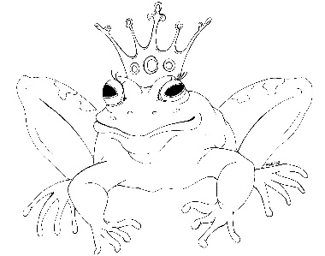
From the Desk of E.D. Baker
Fairy Wings – Discussion Questions

1 What would you do if you saw a goblin?

2 If you suddenly sprouted wings, what would you want them to look like?

3 Tamisin tried to think of reasons for why she suddenly had wings. What possible reasons did she mention? Name some other reasons that someone might get wings.

4 How old do you think people should be when they are told that they were adopted?

5 Name three things that you would add to the menu at the Green Beatle Inn.

6 What kind of goblins ran the Green Beetle Inn?

7 What did the three gray woman share between them?

8 Hipporines are a combination of horses and wolverines. Explain what creatures you would combine and what they would be able to do.

9 How did Jak feel about taking Tamisin to his uncle, Targin?

10 What did Nihlo tell Tamisin when he came for her at the Sograssy Sea? How did it make her feel?

11 Why did Nihlo want to capture Tamisin?

12 Why was Nihlo so nasty to Jak even when they were very young?

13 How did Lorinda feel about Titania?

14 At the end of the story, what do you think Lorinda planned to do with Tamisin?

