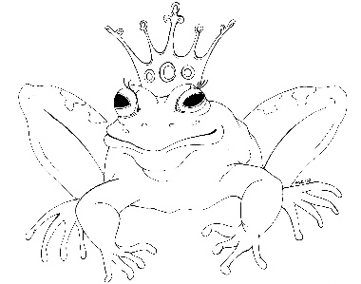
From the Desk of E.D. Baker
Fairy Tale Matchmaker – The Magical Match – Discussion Questions

Why does Cory want to keep secret the fact that she's Cupid?

How does Shimmer help Cory?

Why was there a mix-up with the gowns at Quince's wedding?

Why do some of the witches in Witches United want Laudine to give up her position as president of the guild?

Why did someone send a ghost to scare Cory?

Which Big Baddy was hiding in Shimmer's cave? Why was it one of the worst places he could have chosen?

What exam was Blue studying to take?

Why does Laudine want to help Cory?

Why did Cory and Blue come in third in the race at Delphinium's wedding?

What was the worst part of the goblin wedding?

What else could they sell at the witches' trade show?

Aside from making matches, how did Cory becoming Cupid affect her life?

