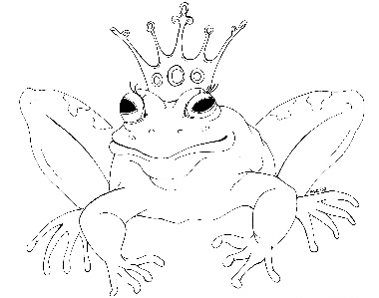
From the Desk of E.D. Baker

Unlocking the Spell – Discussion Questions

Annie didn't want to help Beldegarde find the dwarf at first. What changed her mind?

Why didn't Annie want Gwendolyn to accompany them when they went looking for the dwarf?

What happened to Granny Bentbone after Annie visited her cottage the first time?

Why did Mother Hubbard let a bear into her cottage the winter they met?

How did Rose Red really feel about Beldegarde?

When Annie and Liam met Puss in Boots, how did they know that he was lying?

Why was Annie upset with Liam when they hunted for the dwarf?

Why was the fairy, Moonbeam, mad at Annie and Liam?

How did the dwarves treat Snow White?

Why was Snow White's stepmother able to get away with so many awful things?

Why didn't the magic mirror tell the wicked queen about Annie's effect on magic?

