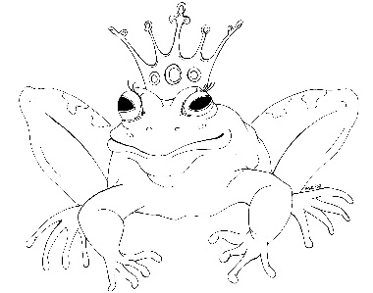
From the Desk of E.D. Baker
Dragon Kiss – Discussion Questions

Why didn’t Audun’s grandmother want him to look for Millie?

How did Audun find Millie?

What special senses does an ice dragon possess?

What would have happened to Audun if he’d swallowed the chunk of ice from the wall of the dragon stronghold?

How did the chunk of ice come in handy later on?

What did Audun have to do if he wanted to win Millie’s hand?

What changed King Stormclaw’s mind about helping Audun?

What tasks did King Stormclaw’s counselors want Audun to perform?

How does the desicca bird care for its young?

How did Audun prove that he would make a good human?

Why was it dangerous for Audun to visit the Magic Marketplace?

How did Olebald Wizard follow Audun to the dragon stronghold?

Describe how you think Olebald escaped from the ice dragons.

What do you think King Cadmus did with his brother, Dolon, after winning his castle back?

If you were an ice dragon, what would your special talent and your name be?

